

Xóchitl Analí Cabañas Mota

NAO ID: 3319

September 15th, 2025

In-Mexico Program Backend Developer Certification

GitHub and Digital Repository Management:

**Final – GitHub**

# Business Overview

A technology company aiming to standardize collaboration workflows. The main goal is to accelerate new developer onboarding and ensure best practices in version control.

# Problem Context

Need: New developers lacked a clear process to configure Git and integrate with GitHub, causing delays in collaboration.

Example: Developers with no prior Git experience struggled with installation, configuration, and contributing to repositories.

# Hypothesis

If new developers follow a guided workflow for installation, configuration, and GitHub practice, then they will integrate faster into the team, adopt better version control practices and reduce errors when managing branches and pull requests.

# Backlog

|  |  |  |  |
| --- | --- | --- | --- |
| **Requirements** | **Stages** | **Time estimation** | **Deliverables** |
| The system must allow developers to configure a Git environment that supports collaboration within the company. | 1 | 1 | * Git installed and configured on the machine (installation screenshot) * .gitconfig file with credentials * Proof of successful connection (screenshot) |
| Developers must be able to create and access a corporate GitHub account to contribute to company repositories. | 1 | 1 | * GitHub account created (profile screenshot) * Authentication setup documented (SSH key or 2FA) |
| The system must allow developers to interact with repositories using Git commands. | 1 | 1 | * Repository cloned locally * Commit history visible in git log. * Evidence of git push and git pull working (logs or screenshots) |
| Developers must be able to work on independent branches without affecting the main branch. | 2 | 1 | * New branch created * List of commits with meaningful messages * Branch pushed to remote repository (git push origin) |
| The system must support code review workflows via pull requests. | 2 | 1 | * Pull Request created on GitHub (PR screenshot) * Comments/reviews from at least one team member * Evidence of changes made after feedback (additional commits) * PR approved and merged into main |
| The onboarding process must provide access to company tools, processes, and confirmation of completion. | 3 | 5 | * Onboarding checklist completed (document/task marked on internal platform) * Evidence of practice with company tools * Written confirmation from team lead or manager (email, ticket, or signed document) |

# Roadmap

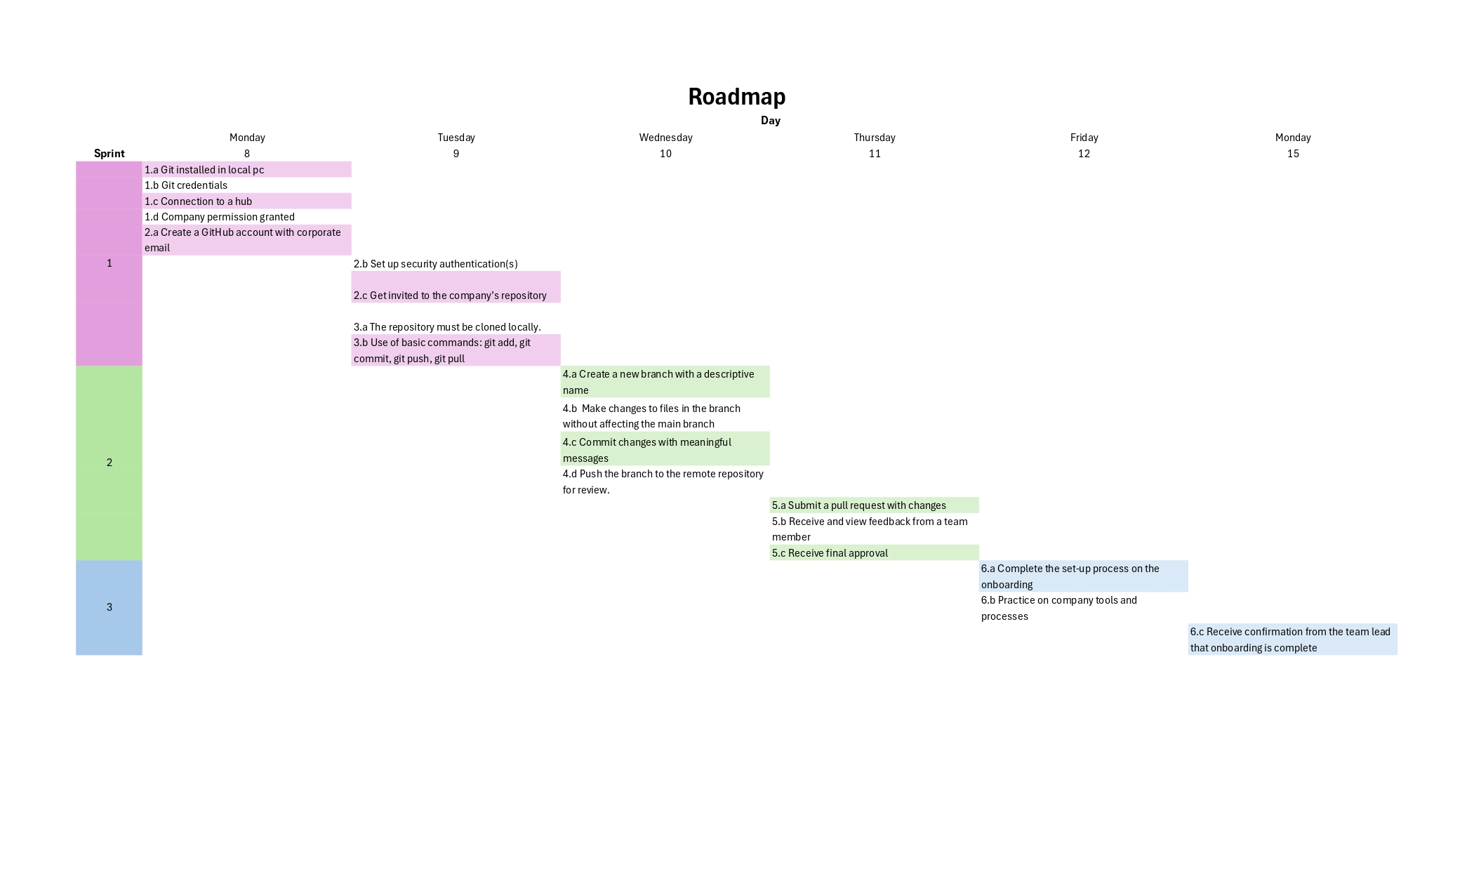

# Evaluation Criteria

**Customer satisfaction:** Developers integrate faster and with fewer errors.

**Scope:** Covers the entire onboarding process, from installation to real collaboration.

**Innovation:** Standardized process that includes active feedback in Pull Requests.

# Solution

Designed and executed a three-phase onboarding process with clear deliverables (screenshots, PRs, checklists).

Validated that new developers completed all activities and collaborated without affecting the main branch.

# Conclusions

**Goal achievement:** Structured onboarding successfully enabled Git adoption for beginners.

**Recommendations:**

* Keep onboarding guides updated.
* Add advanced Git training sessions.
* Automate parts of the checklist with bots or scripts.

**Key learnings:**

* Hands-on practice in controlled environments accelerates the learning curve.
* Pull Request feedback is essential to consolidate best practices.